

FINANCIAL MARKETS & INSTRUMENTS
(FMI)

INDIVUDUAL STOCK CHALLENGE

Tutorial Group

TF01

Name / Student ID

Athan Goh Jun Kang / S10266211D

Trading Notes & Decisions
My overall return was -$2,980, and my portfolio was mostly following the STI’s trend, except during the middle of the simulation, where I traded heavily in U.S and Hong Kong market using DLCs. However, this strategy caused my P/L to dip after mid-May despite it helping me to earn some profit during mid-May. After May, my returns stabilised after starting making profit from my STI stocks such as SIA and Capital Land REITS. Overall, I felt that my portfolio did not perform as per my expectation possibly due to a lack of technical analysis in my trades as I traded mainly through fundamental analysis and news.
Large Cap Stock
I bought ST engineering after receiving a tip from the industry talk on 30 April, one of the speakers said that ST engineering was a safe buy and it is good for holding since it is a company that has multiple contracts signed with the Singapore government and is quite a stable share that does not drop a lot. So, I conducted my own research and technical analysis after that. I saw a 20-50 EMA crossover which gave me a buy signal as it suggests a continuation of an upward trend due to short-term momentum gaining strength over the medium-term trend, something I learned from the same industry talk. Additionally, the company has posted strong earning¹ together with signing of many new contracts worth billions², signalling for a potential bullish run. All these led to me buying the stock as I had enough conviction. I sold the stock once I was satisfied with my profit. However, I missed out on more profits as I had only placed $500 of the stock and the stock did rise from 7.38 to 7.55. So I learned to be more confident about my trades and believe in myself if I had already done my fundamental and technical analysis.
Learning from my past mistake of not trusting in myself and analysis, I decided to increase my risk appetite and I bought $5,000 worth DBS at $43.04 as I knew earnings were coming up the next day and I was confident in their results due to the fact that the US feds has not cut interest rates in a long time, and banks usually thrives in times like this. After earnings was released the next day, after earnings was released, the momentum from it continued for a few days, so I decided to hold, but I had not thought of an exit plan yet, which is a valuable lesson that I have learnt. I did research on how to determine when to sell a stock and it was through this where I learnt about RSI. RSI of DBS showed that it was above 70 multiple times (Appendix, Chart 1), which means that the stock is overbought, probably due to many people wishing to ride the momentum from the strong earnings report. An RSI above 70 usually serves as a sell signal due to potential price pullback or correction occurring. So, I sold my trade at $44.99 to lock in my profit as risk of loss is imminent and I did not want to lose my profits.
ETFs and REITS
Towards the end of the challenge, I bought STI ETFs as I was looking for a something that was stable and did not require much effort of looking after the stock to ensure I am not losing too much. I chose STI as I remembered the presentation from the SGX learning journey and they explained the benefits of investing in STI and one of it was for its stability and while returns may be small, it offers steady and consistent growth overtime, I sold the stock at the end of the challenge as my main strategy for this trade was to buy and hold.
I also bought into REITs, specifically CapitaLand Integrated Commercial Trust (CICT) as a defensive stock that will generate me steady and consistent profits even in times of volatility. I chose CICT as they manage a substantial number of major shopping malls in Singapore⁹, making them a dominant player in the local retail property market. Additionally, these malls have strong and consistent tenant demand due to location where they have a lot of visitors every day, giving me confidence that CICT’s stability. I sold CICT once I was happy with the amount of profit I made which was $180.
Penny Stock
I bought AP Oil during the escalation of the Israel and Iran conflict, which also led to increase in oil prices. Through this, I expected a spillover effect onto other countries' oil company since Iran holds a large amount of the globe’s oil supply and a reduced supply from a key oil-producing region would lead to higher oil prices, which would, in turn, benefit oil companies and increase their stock price. So, I chose an oil company in SGX to make use of this opportunity to test out my hypothesis and if my hypothesis was right, I would buy more of the AP Oil stock. However, the price of the stock went down, proving my hypothesis wrong instead. This taught me that there are other factors such as global demand coming into play other than geopolitical tensions and having a stronger influence on stock prices. In this case, since the world’s demand for oil might not be that strong after all and countries might be shifting to renewable sources of energy especially since sustainability is gaining traction. I sold the stock after I realized that my hypothesis was wrong, and I did not lose that much money from it as I only put in a very small amount, since it was just to test my hypothesis.
DLC
My main strategy for DLCs were to buy them based on hype and news, such as strong earnings or new product releases, aiming to make profit by riding the rally through short-term momentum that is driven by positive market sentiment.
I bought 2,100 3x Long Microsoft DLCs after an EMA crossover and breakout from its resistance (Appendix, Chart 2). This was due to Microsoft beating its earnings⁷ and I expected its stock price to increase further since the stock only increased towards market close and there’s a chance that not many people got to act on it and will do so in the upcoming trading day. However, the underlying stock only increased slightly the next trading day. This is where I learnt a stock can go against its expected trend, showing that trendlines are not a good indicator of whether a stock will go up or down and that short EMA crossovers can lead to false breakouts where the stock price does not increase further even after breaking through the resistance point. After the weekend, I went to check the Microsoft’s RSI value to assess whether I should sell or hold the DLC. I found that RSI was above 70 (Appendix, Chart 3) and that the trade volume was decreasing, which meant that the stock is overbought and not many people are buying more of Microsoft stock anymore. I took this as a sell signal and closed my trade earning a profit of $400. Despite not earning as much profit as expected, it is more important that I prioritised protecting my gains.
I bought 22400 of 5x Short DBS DLCs, as I was convinced from my group of friend’s explanation that DBS share price would drop after ex-dividend day since many would sell the stock after getting their dividends since they are just trading merely for the dividend payout. Additionally, this is also evident in the other ex-dividend day³ where the stock decreased (Appendix, Chart 4). Resultantly, the price of DBS did go down. However, we started losing money on our DLC trades instead and I later learned that their hypothesis was wrong. This is because SocGen has stated⁴ that dividend adjustments are excluded from the daily percentage change of the underlying asset, meaning DLCs do not respond to price drops resulting from dividend payouts. I tend sold the DLC immediately after I realised this mistake. As a result, I lost $478 from this trade. This trade has taught me to not trade solely from the word of mouth and to always fully understand the financial instrument that I am trading, down to its minute details to prevent blunders.
Initially, I bought 29,000 of 5x Long Xiaomi DLCs at $0.410, (a total of $11,890) at the end of May, as Xiaomi was going to showcase the features of their upcoming electronic SUV that is waiting to be released. Public sentiment was very positive about this piece of news as they felt that it would beat Tesla’s Model Y electronic vehicle⁵. Thus, I locked in that trade as I was very confident about my market analysis as there was a potential rally for Xiaomi’s stocks. However, a few days later, it was announced that the official launch of the YU7 SUV is expected in July⁶, which was a month from then. Many people were expecting the launch of Xiaomi’s smart vehicle to start during the feature showcase. Thus, the hype for the stock died down and dropped. But I was still convinced about my fundamental analysis, so I doubled down and continued buying more Xiaomi Long DLCs despite the price drop as I thought I was getting the DLC at a discount. The DLC price kept on dropping afterwards but I had accumulated 115,000 of the DLC overtime ($35,000) through persistent buying despite the price drop (Appendix, Xiaomi DLC). Finally, I made the tough decision to sell 1/3 of my total Xiaomi DLCs amount at $0.265 to cut loss and keep the rest in case there is a market correction to gain back some of my losses and to my surprise, there was a market correction, and I managed to sell the rest of my DLCs at $0.325 (Appendix, Xiaomi DLC 2). I suffered the most from this trade throughout my whole trading journey. Through this, I learnt not to put too much of my capital into one trade. As I had spent about $35,000 in a singular DLC, causing me take up a lot of losses when the hype of Xiaomi's yu7 died down. However, I also learnt not to sell everything one shot even if I’m losing money on my trade. The strategy of selling my DLCs batch by batch helped me recoup some of my losses as I was still confident about my fundamental analysis since the release of YU7 SUV was just later than expected and it is still bound to be released and be a strong competition to Tesla's Model Y.
Structured Warrant
I bought a HSI call warrant trade as I remembered one of the speakers during one of the industry talks said that the Hang Seng Index is quite a volatile market and that it is a good choice for those who are willing to take big risk to make more profits. When I looked deeper into the warrant, it had a high trade volume of buying and selling coupled with a very tight spread of $0.001. This gave me conviction that the warrant was very liquid, and I did not have to worry about liquidity risk. Additionally, I compared the different HSI warrants that was offered in SGX and selected the one with the highest gearing (Appendix, HSI Warrant) and the most responsive one to maximise on my potential returns. I got complacent and decided to make the trade without doing any sort of Fundamental analysis about HSI and bought $5000 worth of the warrant at $0.024. I saw returns the next day, earning $400 and got greedy as I thought the warrant would continue to go up. However, the warrant price started coming down and I made the decision to close my trade to cut my loss, I lost $860 from this trade. This has thought me the tough lesson to never trade blindly without doing any sort of Technical and Fundamental analysis especially if I’m trading very risky and volatile products such as warrants and I paid a huge price for this lesson.
Useful InvestingNote Function
A useful InvestingNote feature would be its Event Calendar, which helps keep track of important corporate events. It captures key dates such as dividend payouts, earnings report releases and AGMs. This tool is helpful for planning trades, since volatility of the stock will increase closer to important dates such as earning reports. For example, I can see when is DBS’s ex-dividend date (Appendix, InvestingNote Feature), and I used that information to make trades accordingly, where I tried to short the stock as I anticipated a price drop of the underlying DBS stock. Even though my plan did not work due to way DLCs work, I still managed to predict the price drop of DBS stock price. It also helps me identify dividend-paying stocks ahead of time so I can decide whether to buy before the ex-dividend date to gain some profit from the payout. Overall, the Event Calendar makes it much easier to stay informed and it saves me time from researching important dates as everything I need is compiled on 1 page.
2 Useful CIQ Functions
First CIQ Function
One useful CIQ function I used during my trading journey is the Peer Comps function. It allowed me to compare a stock against its competitors based on the company’s financial highlight reports and performance report. One example of me using this function was when I was deciding which of the banks listed in SGX I should trade. I was conflicted between DBS, UOB and OCBC. Using the Peer Comps function, I was able to find the best stock out of the 3 banks. DBS came up on top against UOB and OCBC as it the peer comps showed that it had the highest in “Total Return in 5 years” (Appendix, Comps 1) and even though UOB and OCBC did not have any ROAE (return on average equity) value, DBS had one of the highest ROAE value across banks stocks from different markets (Appendix, Comps 2). This proves that DBS is a good buy as it has strong company performance against its peers and has helped me in my decision making for future stock purchases whenever I am conflicted between stocks that are within the same sector.
Second CIQ Function
Another CIQ function that I found useful was the chart explainer function, which helps to explain why a stock moved the way after selecting a time period that I want to it to analyse. It analyses the movements of the stock’s price chart and links them to relevant news events that occurred during that period. (Appendix, Chart Explainer)
This has been extremely helpful in helping me understand the story and reasoning behind the change in stock price, without having to do extensive research, thus saving me a lot of time.
For example, when I was reviewing my Xiaomi DLC trade to find out for more reasons to Xiaomi’s stock price drop. I used the Chart Explainer to trace back to the stock's price drop and found that there was indeed more to the reason for the price drop than just the delayed launch of the YU7 SUV. It was also caused by a fatal crash involving its previous model, the SU7, which caused Xiaomi to face increased scrutiny regarding its marketing practices and safety features and affected consumer’s confidence in its products. Overall, this feature improved my post-trade analysis and saved me time in research in finding out the reasons to price movements.
End-of-Challenge Reflection
Fully Understanding Financial Instruments’ Mechanics Before Trading
The incident with DBS shorts before its ex-dividend price drop taught me the important lesson in fully understanding the financial instrument before making trades with them to avoid making silly mistakes that will cost me to lose money unnecessarily. I assumed that DLCs behave exactly like their underlying stocks. However, I later found out that dividend adjustments are excluded from DLC pricing when I was figuring out why I lost money on my DLC shorts despite the underlying stock price decreasing. This misunderstanding caused an unexpected loss. From this, I learned the importance of fully understanding the mechanics of the financial instruments I trade, instead of relying on assumptions or second-hand advice. Thus, I applied this lesson to my future trades, such as fully understanding the nature of structured warrants. I made sure I fully understood the concepts such as gearing, expiry date and moneyness before making a trade with them and to read all the details about them on Macquarie’s website⁸ to prevent misconceptions.
Importance of Both Fundamental and Technical Analysis in Every Trade
Through the stock challenge, I learnt the importance of doing both fundamental and technical analysis for every single trade, and not getting complacent or lazy, especially after I start seeing some success from my trades. There were times when I traded off advice from others without doing any sort of TA or FA, leading to poor entry points as I did not check for overbought signals such as RSI or support and resistance levels. One example was the purchase of the HSI call warrant, where I traded merely on advice from someone else without doing my full due diligence of TA and FA, causing me to lose money from that trade. Thus, the overarching lesson is that there is no shortcut for proper analysis in trading, both FA and TA must be done to make smarter and more wise decisions. Despite this stock challenge not involving any real money, doing TA and FA before making a trade is a must for every trader regardless of whether there is any real monetary value involved, and it is a good habit to cultivate.
Managing Between Emotions and Risk Exposure
One of the most impactful lessons came from my big Xiaomi DLC trade, where I ignored basic risk management because of my strong conviction of Xiaomi’s fundamentals analysis. I overcommitted by putting nearly $35,000 into a single instrument in batches despite the price of the DLC dropping, expecting a comeback from the strong rally of the YU7 SUV launch. However, when the loss got too much, I had to sell my DLCs at a loss. This incident taught me to avoid emotional averaging down to try and “fix” my trade when it is moving against me. It is more important to diversify my portfolio, and to always have an exit strategy or back up plan, regardless of how confident I feel about the trade.
Luckily, I did not lose any real money in this stock challenge, which allowed me to learn these 3 valuable lessons without any financial consequences.
Becoming a Self-Directed Learner Over the 9-Weeks
I became much more self-directed in my learning process through this challenge. I developed this habit of constantly trying to find out the reason behind why certain situations are as such, such as the incident where I lost money on DBS shorts. I also tried to figure out ways to improve my strategies, such as learning about RSI and EMA when I needed to think of when to enter or exit a trade. I did not learn much about trading strategies and tips from classroom content, so I took the initiative to explore CIQ Pro tools like the chart explainer to try to understand the reasons behind the stock’s price changes and used InvestingNote's event calendar to track dividend dates and earnings reports. Each trade, whether a win or a loss, became an opportunity for me to reflect, research, and refine my strategy accordingly. I actively looked up market news, studied indicators, and even noticed patterns in the market such as STI morning breakouts where SGX stock prices have the tendency to increase at the very start of the day. This challenge has developed my mindset of taking ownership of my own learning and taught me the value of discipline and continuous learning.

References
1. ST Engineering delivers record revenue and net profit in 2024. (n.d.). ST Engineering. https://www.stengg.com/en/newsroom/news-releases/fy2024/
2. Lim, C. (2025, April 28). ST Engineering wins new contracts worth S$4.4 billion in Q1 2025. The Business Times. https://www.businesstimes.com.sg/companies-markets/st-engineering-wins-new-contracts-worth-s4-4-billion-q1-2025
3. Dividend Information | Investor Relations | DBS Bank. (n.d.). DBS. https://www.dbs.com/investors/financials/dividend-information
4. SIPs. (n.d.). GUIDE TO DAILY LEVERAGE CERTIFICATES. https://dlc.socgen.com/home/pdf/SG_Brochure_DailyLeverageCertificates.pdf
5. China’s Xiaomi to start selling YU7 in July, a rival to Tesla’s Model Y. (n.d.). Reuters. https://www.reuters.com/business/media-telecom/chinas-xiaomi-founder-expects-new-electric-suv-hit-market-july-2025-05-22/
6. Zhang, P. (2025, July 4). Xiaomi founder says official launch of YU7 SUV expected in Jul. CnEVPost. https://cnevpost.com/2025/05/22/xiaomi-yu7-official-launch-jul/
7. Subin, S. (2025, May 1). Microsoft pops more than 7% after earnings beat, posts best day since 2022. CNBC. https://www.cnbc.com/2025/05/01/microsoft-pops-9percent-after-earnings-beat-on-pace-for-best-day-in-5-years.html
8. Singapore Warrants | Trading Stocks and Index Warrants | Macquarie. (n.d.). https://www.warrants.com.sg/education/brochure
9. CapitaLand Integrated Commercial Trust - Investor Relations: IR Home. (n.d.). https://investor.cict.com.sg/

Appendices
Total Return Screenshot
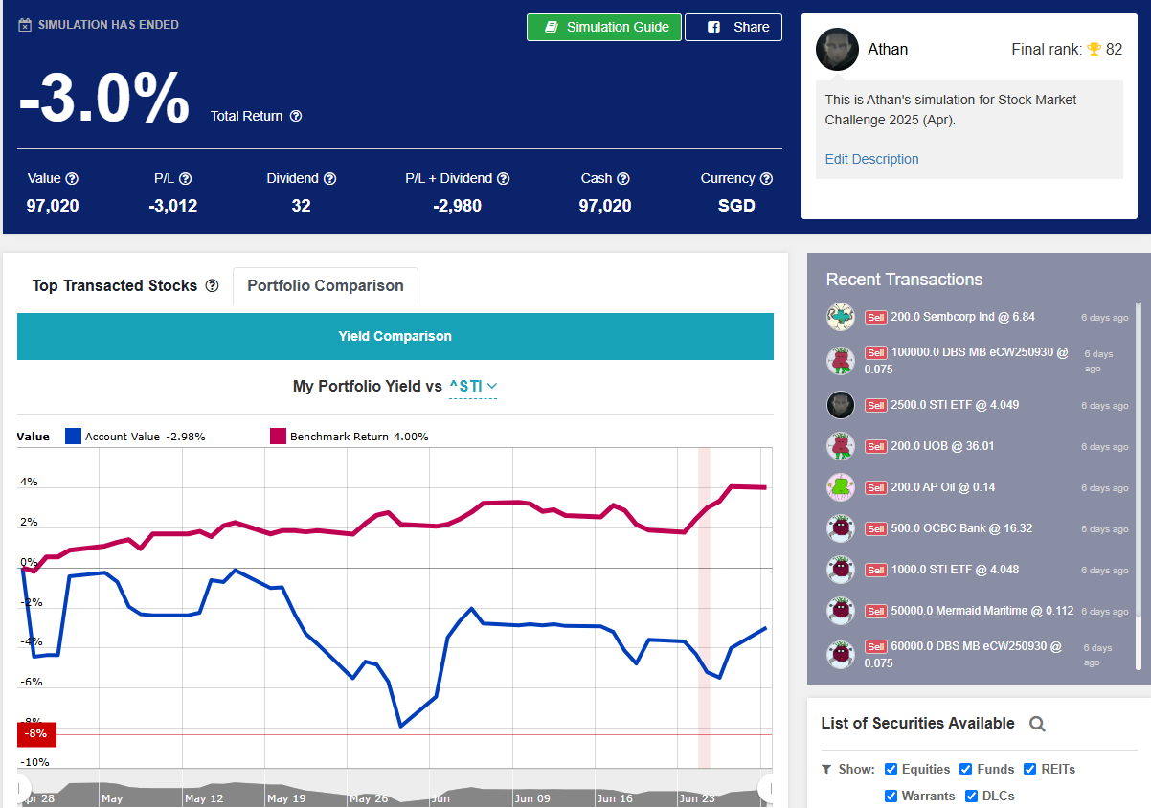

Summary Position Screenshot 1
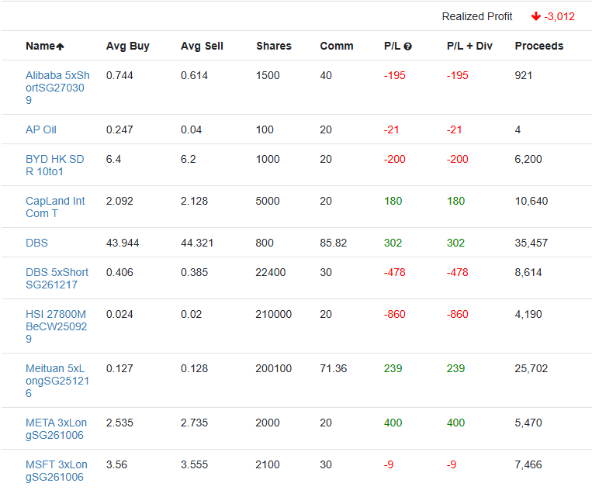

Summary Position Screenshot 2
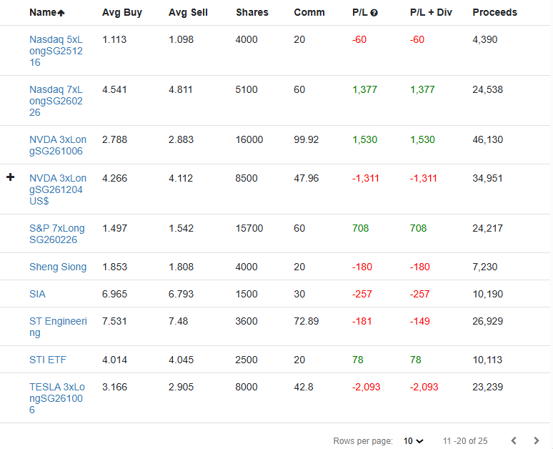

Summary Position Screenshot 3
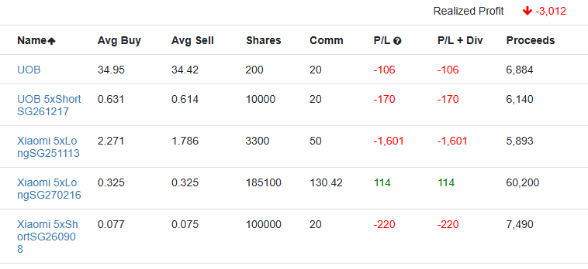

Order Screenshot 1
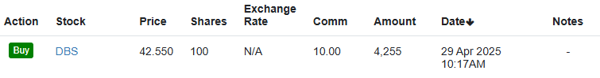
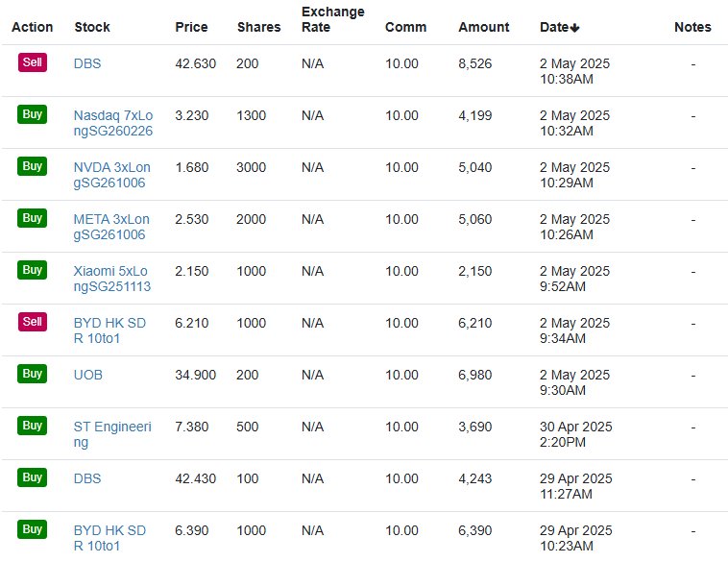

Order Screenshot 2
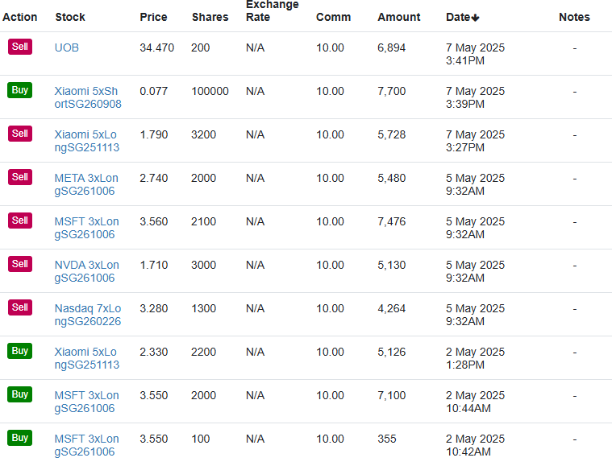

Order Screenshot 3
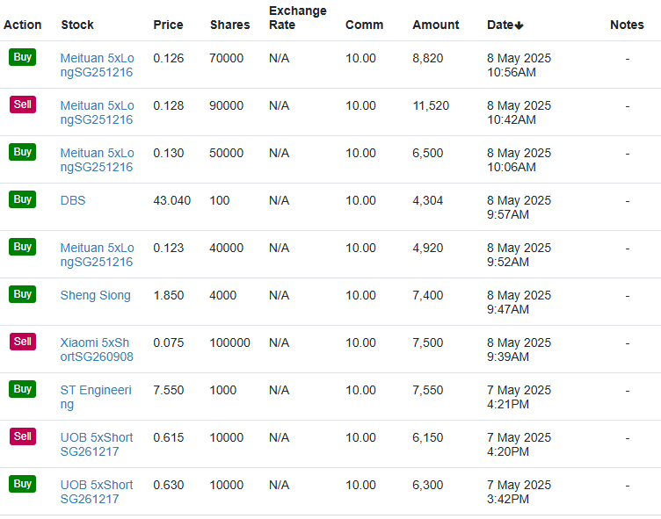

Order Screenshot 4
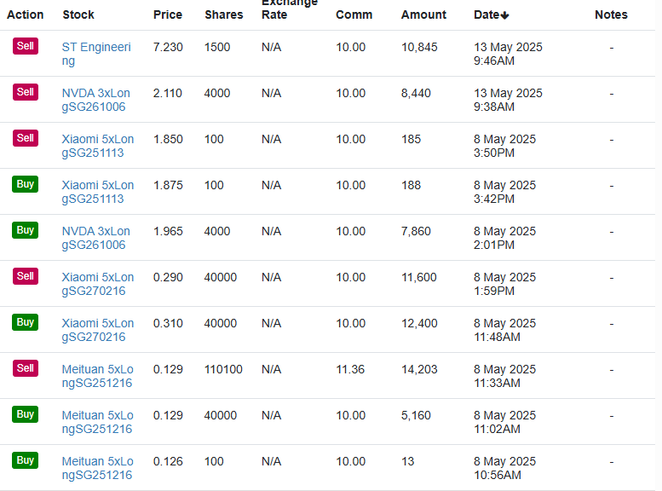

Order Screenshot 5
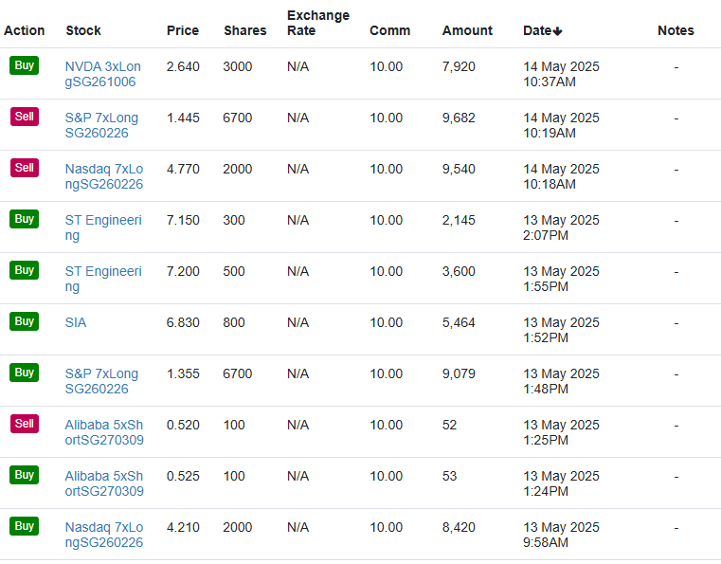

Order Screenshot 6
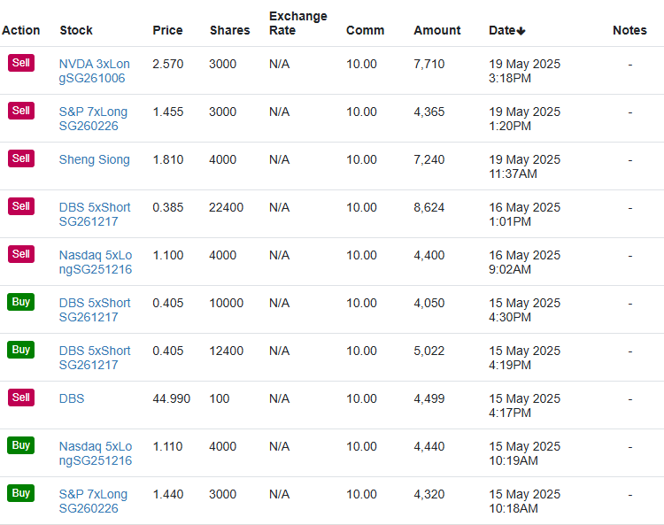

Order Screenshot 7
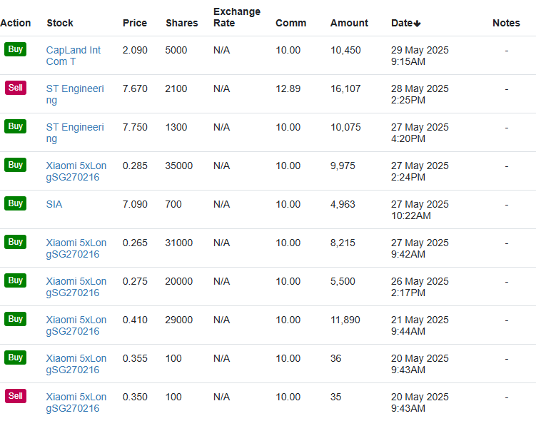

Order Screenshot 8
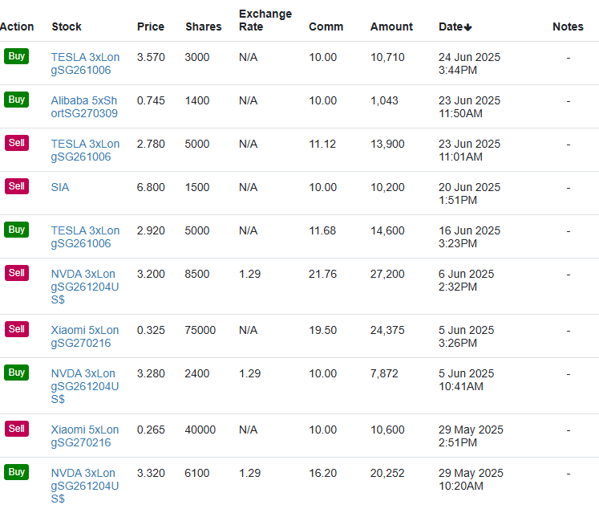

Order Screenshot 9
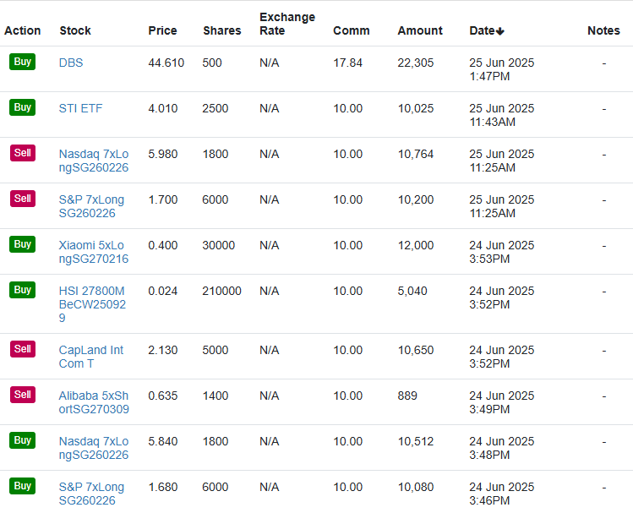

Order Screenshot 10
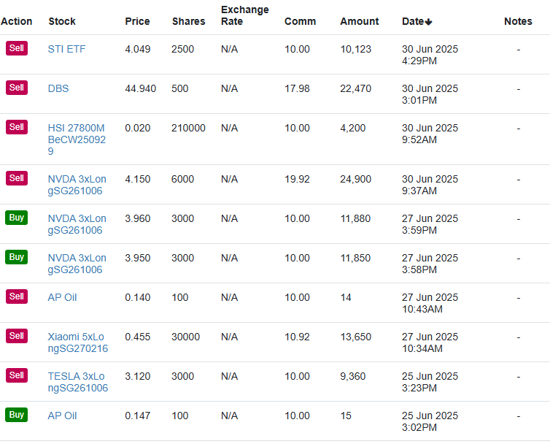

Chart 1
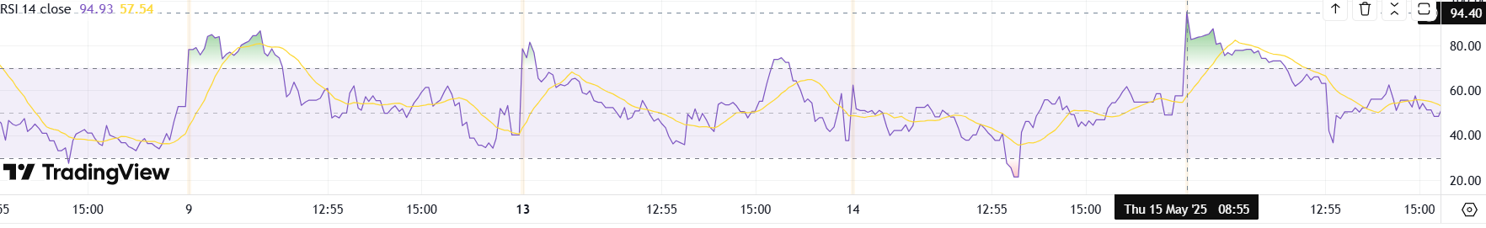
Chart 2
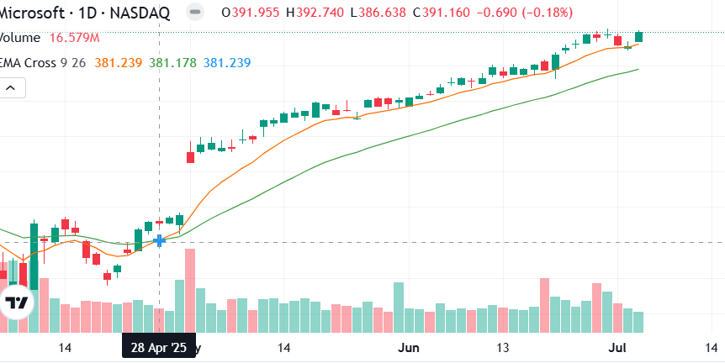
Chart 3
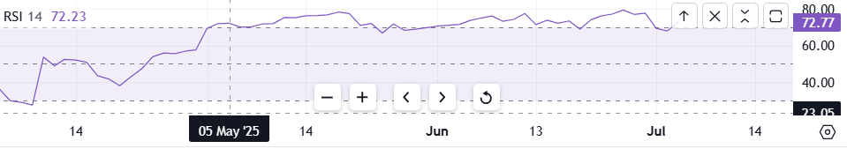
Chart 4
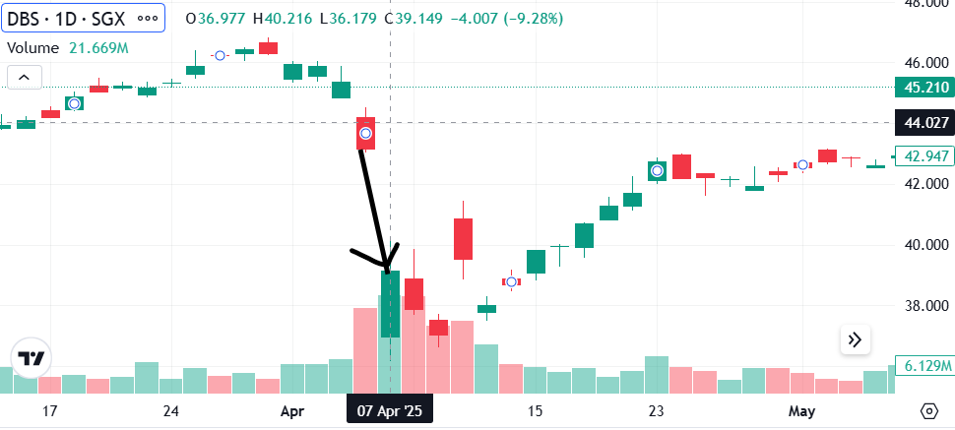
Xiaomi DLC
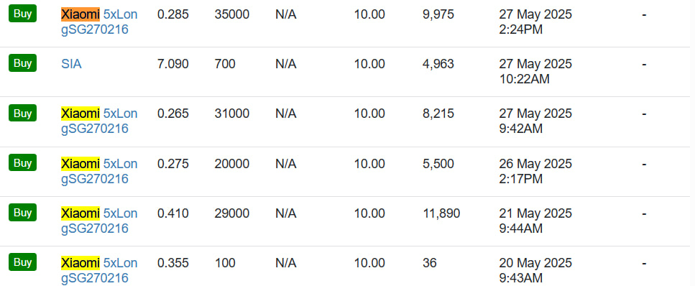
Xiaomi DLC 2
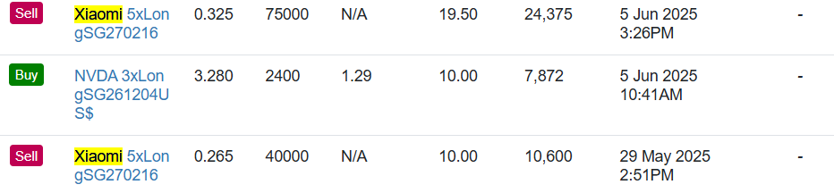
HSI Warrant
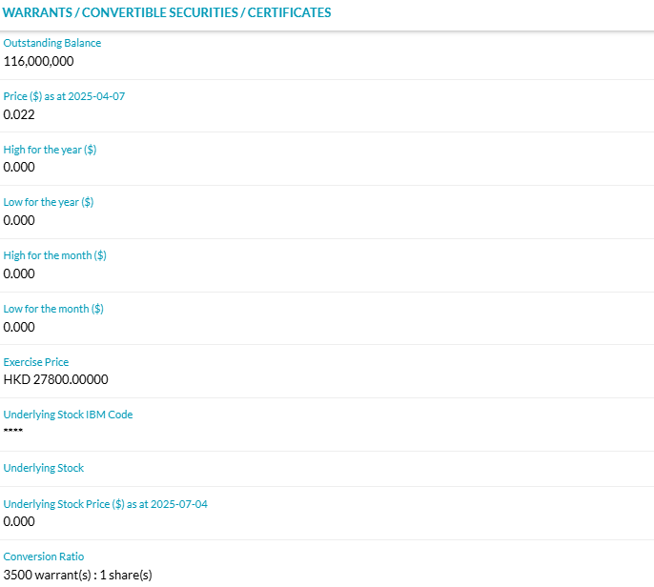
Index price= 24,177.07 as of 24 June when I bought
Warrant price= 0.024 as of 24 June when I bought
Gearing= 24,177.07 / (0.024 x 3500) = 287.822x

InvestingNote Feature
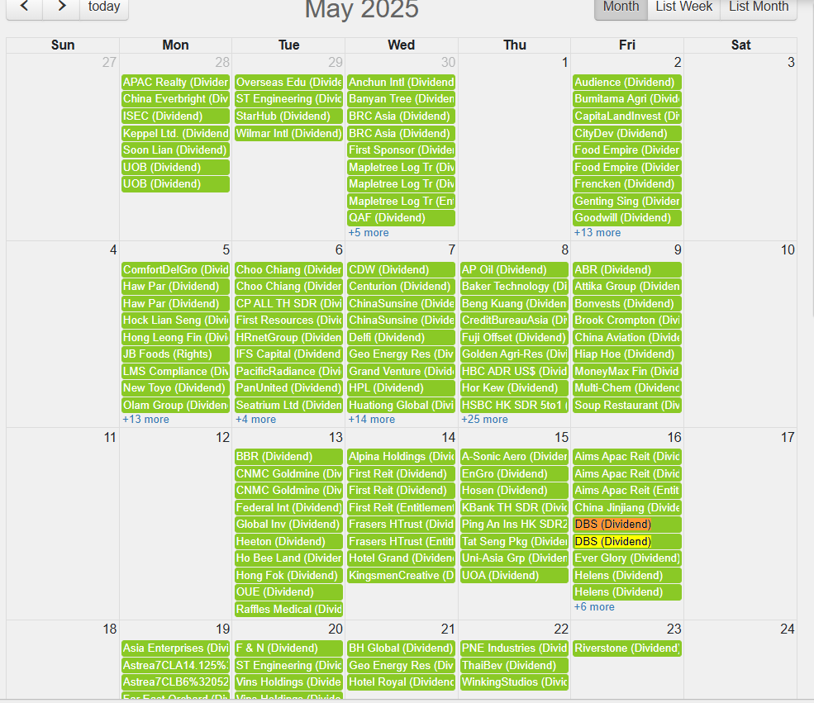
CIQ Function
Comps 1
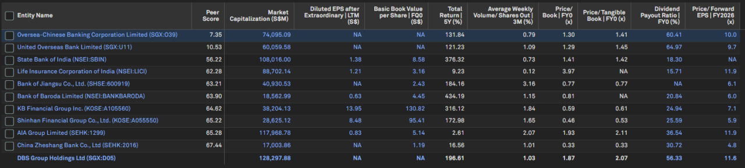
Comps 2
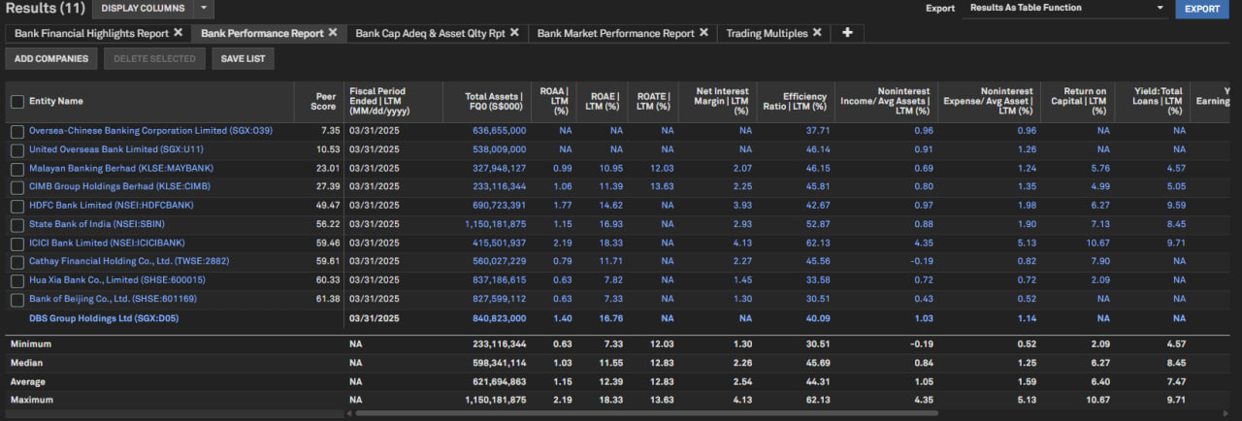
Chart Explainer (highlighted parts of chart explainer output are the parts I focused on)
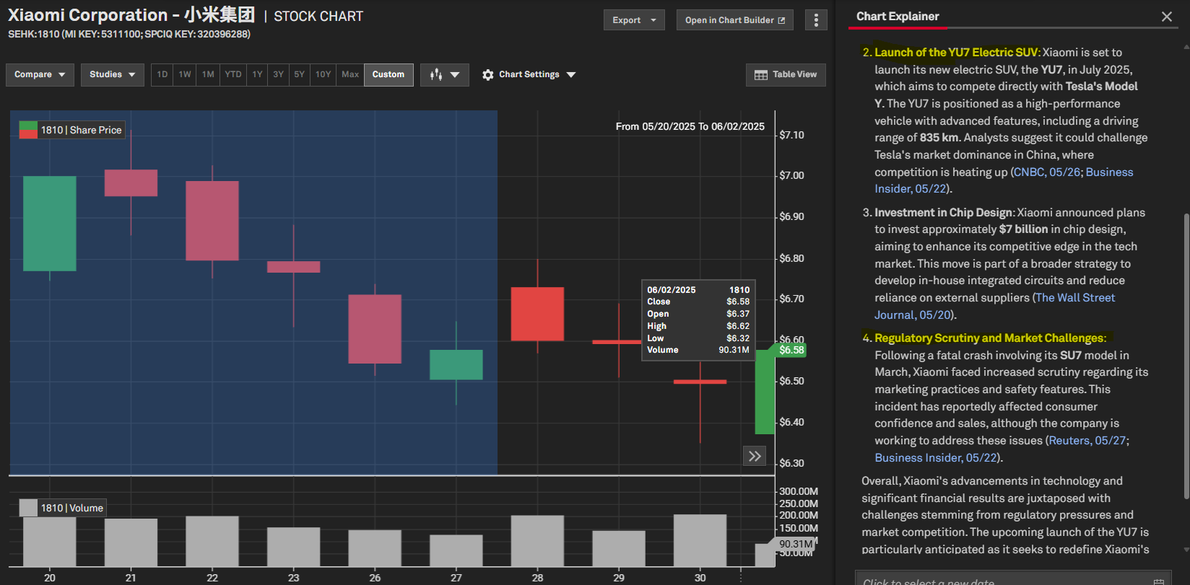

Disclosure Statement for Use of Generative AI | (W.e.f April 2025 semester)
For students who did not use any generative AI tools
Name of student(s): Athan Goh Jun Kang
Module & Tutorial Group: Financial Markets & Instruments/ TF01
I/ we declare that the submitted work was produced without using any generative AI tool for idea generation or improvement of original writing. I/we am/are aware that any failure to declare the use of generative AI will be considered as an act of academic dishonesty and students found guilty will be dealt with in accordance to the NP Plagiarism Policy.
For students who have used generative AI tools
Name of student(s): ___________________________________________________________________________________________
Module & Tutorial Group: ______________
Part 1
Specify the generative AI tools used and the respective purposes.
 |  | Generate materials for background research  Note: Materials produced by generative AI tools need to be  referenced to avoid plagiarism  [Put an “X” in the appropriate box(es) below] | Improve the academic tone and accuracy of language, including grammatical structures, punctuation and vocabulary  [Put an “X” in the appropriate box(es) below] | Others  [Specify use below]
ChatGPT
Grammarly
GrammarlyGO
Marmof
QuillBot
[
Specify
name

of
Gen AI
 | l]
Part 2
List the prompts used in the generative AI tools
Generative AI Tool | Prompt/ Link* for Chat Content
9

